DS 522 Data Acquisition and Analytics
HOS09A –Data Aggregation
10/30/2025 Reviewed by Ashwin Paturi
04/30/2026 Reviewed by Vishal Krishna Kumar
05/28/2026 Reviewed by Namrata Mali

School of Technology & Computing (STC) @ City University of Seattle (CityU)

Take Note Before Starting
- The directory path shown in screenshots may be different from your directory.
- Not every step is explained in the tutorial. If you are not sure what to do:
1. Consult the resources listed below.
2. If you cannot solve the problem after several tries, email your course TA for help.
Learning Outcomes
- Understanding data aggregation in Pandas
- Understand how to create group objects.
- Grouping data using ‘groupby()’ function
- Applying aggregation functions like agg, apply, and transform into groups.
- Perform multiple aggregations simultaneously on different columns using custom aggregation functions.
Resources
- McKinney. (2022). Python for Data Analysis (3rd edition).
- Tutorials Point. (2024). Python Pandas – GroupBy. https://www.tutorialspoint.com/python_pandas/python_pandas_groupby.htm

Getting Started
- Open the VS Code and, within the VS Code, open the DS522 course folder created earlier. On the menu tab, select File, then Open New Folder. Navigate to your work directory or to the GitHub repository you cloned.
Example: C:\ Desktop\DS522 OR C: \Desktop\DS522\github_repository_name
NOTE: If you have cloned a GitHub repository that is provided specifically for this course, navigate to that directory, and skip steps 2 to 4. This will be the folder where you will be storing all your HOS09A work.
- Once in your work directory, go to the menu tab again, select Terminal, select New Terminal to open a Command Line Interface (CLI) like the Command Prompt or PowerShell for Windows OS.
- Inside your “DS522” directory, create a new directory and name it “HOS09A”. Use the following command: >mkdir HOS09A
- Move to the new directory. Use the following command: >cd HOS09A
NOTE: This will be the folder where you store all your HOS09A work.
Data Aggregation: Data aggregation is an essential piece of extensive data analysis and efficient summarization. We will explore aggregations in Pandas, from simple operations to more complex ones, all based on the concept of “groupby.”
Here is a list of commonly used aggregation functions in Pandas for data aggregation:
- mean () - Calculates the mean (average) of numeric columns for each group.
- sum () - Returns the sum of the values for each group.
- min () - Identifies the minimum value within each group.
- max () - Identifies the maximum value within each group.
- count () - Counts the number of non-null values in each group (can be used for categorical data as well).
- median () - Returns the median value of numeric columns within each group.
- mode () - Retrieves the most frequent value(s) in each group.
- std () - Calculates the standard deviation of values within each group.
- var () - Computes the variance of the values within each group.
- quantile(q) - Returns the value at the given quantile (e.g., quantile(0.25) for the 25th percentile) within each group.
- prod () - Returns the product of the values within each group.
- first () - Retrieves the first non-null value in each group.
- last () - Retrieves the last non-null value in each group.
- nunique() - Counts the number of unique values in each group.
- agg() - Allows the application of multiple aggregation functions simultaneously (a mix of built-in and custom functions).
- apply() - Applies a custom function to each group (more flexible than agg() and allows for more complex transformations).
- transform () - Like apply() but used for transforming group values while keeping the same shape as the original data (often used for group-wise normalization or scaling).
- cumsum() - Computes the cumulative sum within each group.
- cumprod() - Computes the cumulative product within each group.
- sem() - Calculates the standard error of the mean for each group.

These aggregation functions are key in summarizing, analyzing, and transforming grouped data in Pandas. You can apply these functions either directly or within a more complex operation using groupby(), agg(), apply (), or transform () methods.

- In your HOS09A folder or repository, create a new file by clicking File on the top menu bar, then New File, and selecting the Jupyter Notebook option. Save the file with CTRL + S, rename it to data_aggregation.ipynb.
- Type the following code and run the code cells to load and see the data that we will be working on:

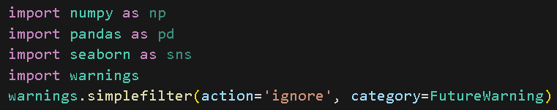
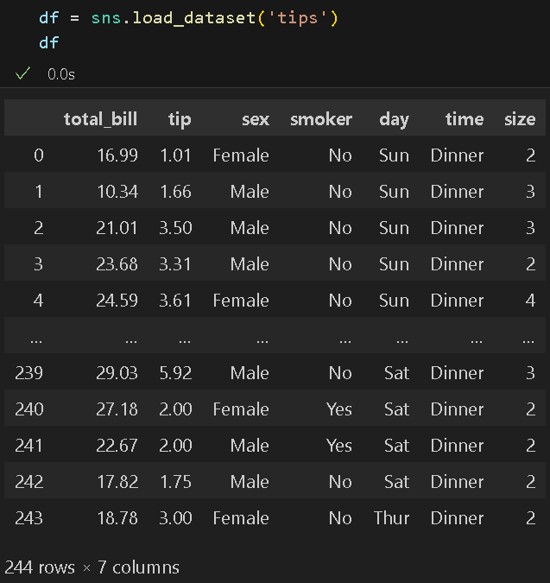

- First, let us perform a quick exploration of our data to check for missing data. Type the following code in a new code cell, then run it to see the results:
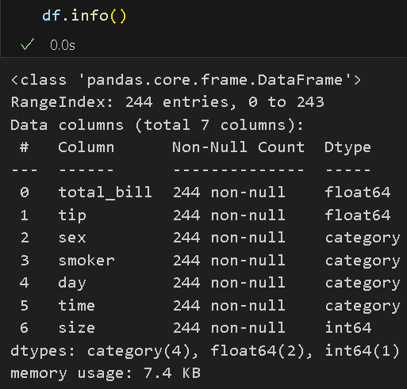
As we can see, we do not have to worry about missing values.

- Let us execute some basic aggregation operations in Pandas. Enter the following code in new code cell and run it to observe the results:

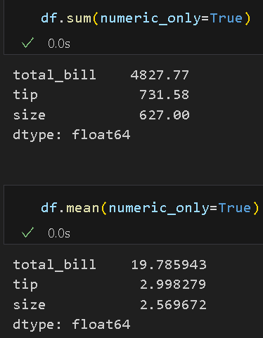
In both instances, we specify that the operation be performed on columns that contain numeric values. This is to avoid TypeError when your data includes columns with string, Boolean, or even datetime values, which is quite common in real-world data.
Additionally, when dealing with large amounts of data with many missing values, it is convenient to set skipna=True when calling these built-in aggregation functions. For this example, use: df.mean(numeric_only= True, skipna=True).

- A more convenient way to return several common aggregations for each column in a DataFrame is using the describe() function. Type the following code in a new code cell and run it to see the results:
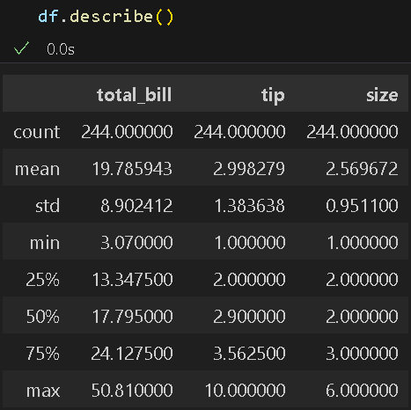

GroupBy: Next, let us explore data aggregation in more depth by delving into groupby operations, which provide fast, efficient data insights. The term 'groupby' is derived from a SQL command. Any groupby operation involves one of the following operations on the original object:
- Splitting the Object
- Applying a function
- Combining the results
In many cases, we divide the data into subsets and apply specific functions to each of them. When performing the apply functionality, we can perform the following operations:
- Aggregation − computing a summary statistic.
- Transformation − performs some group-specific operations.
- Filtration − discarding the data with some conditions.

- First, let us perform a groupby operation on the entire DataFrame. Type the following code in a new code cell and run it to see the output:

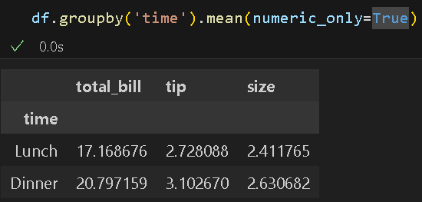
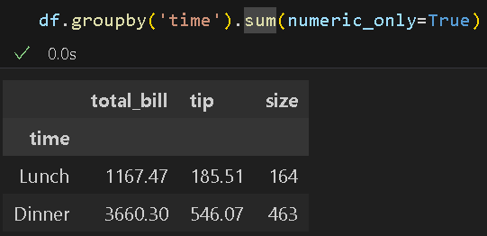

Note that the data we are using has non-numeric columns; thus, it is necessary to pass the numeric_only=True option; otherwise, this will cause a TypeError.

- Now, let us perform the sum operation on a single column using column indexing. Again, type the following code in a new code cell and run it to see the output:

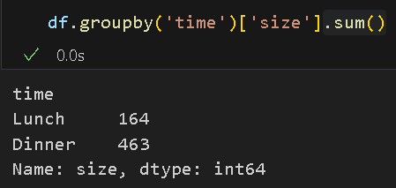

This time, we did not pass the numeric_only=True option, which is unnecessary in this case since we are dealing with a single column, and the ‘size’ column contains numeric values. Take note that no computation is done until we call some aggregation function on the groupby object. Simply calling groupby() to a Series or DataFrame, i.e., df.groupby(‘time’), will only create a groupby object.

- The groupby object also supports iteration that returns each group as a Series or DataFrame. Type the following code in a new code cell and run it to see the output:

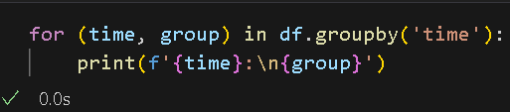
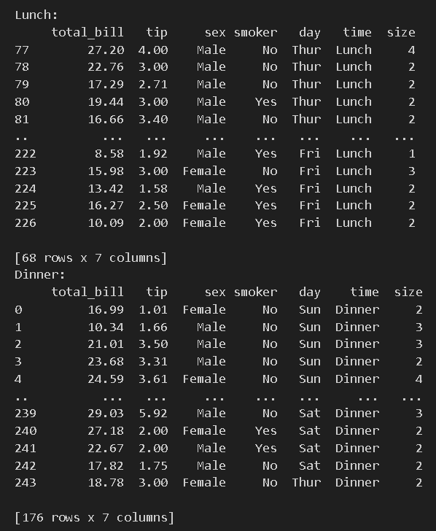

As you can see, this is as if you were looping through a list [(lunch, data that has
Lunch value (dinner, data that has dinner value)].
- Now, let us try using multiple keys. Type the following code in a new code cell, then run to see the output:

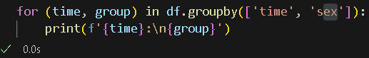
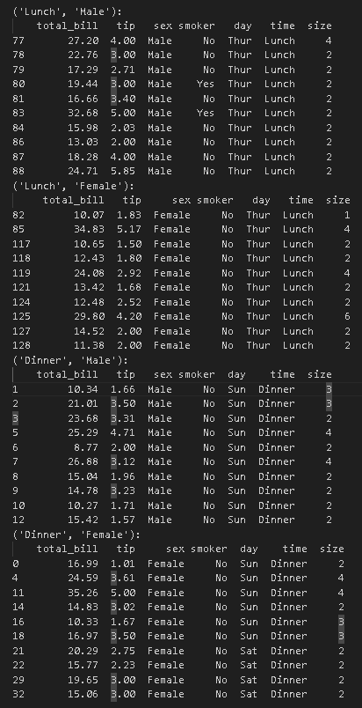

Note: This only prints the first 10 results.

- Thanks to some Python class magic, any method that is not explicitly implemented by the groupby object can be passed through and executed on the groups. Enter the following code in a new code cell and run it to observe the output:

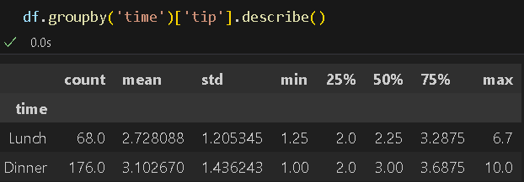

We can see that describe () is applied to each group and then combined within the groupby object. We can use any valid DataFrame or Series method in this way.

Aggregate, filter, transform, and apply: As mentioned previously, the groupby object provides aggregate () (or agg(), filter (), transform (), and apply () methods that perform a variety of useful operations before combining the grouped data.
Aggregate or Agg: We will use the aggregate function to demonstrate how it offers more flexibility than previous groupby aggregations with sum (), median (), etc.

- Type the following code in a new code cell and run it to see the output:

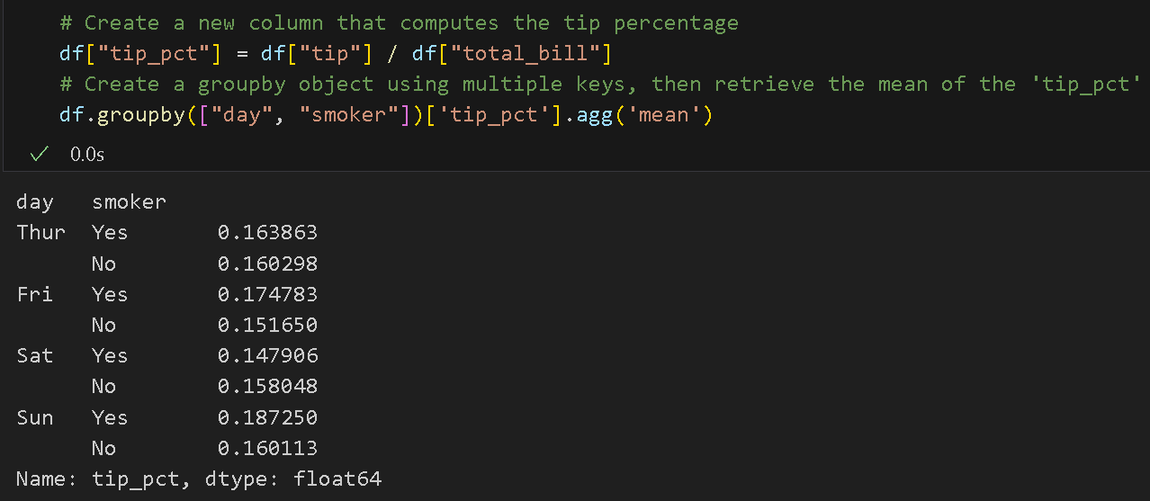

Note that aggregate/agg can take a string function name, a function, or a list of functions, and compute all the aggregates simultaneously.

- In the previous example, we passed a single string function name or a function; this time, let us perform and pass a list of functions or function names. Type the following code in a new code cell, then run to see the results:

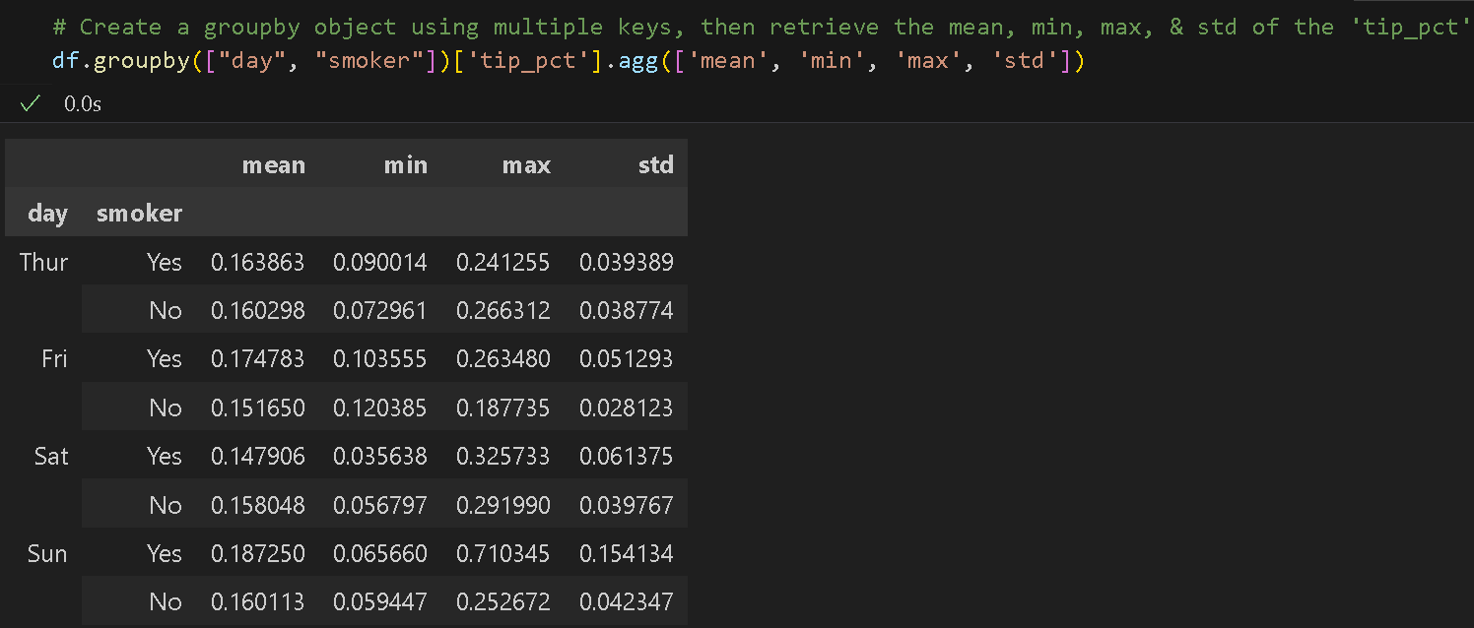

As you can see, the code above produced a DataFrame with column names taken from the functions in the list. When we pass a list of aggregation functions to agg(), they are evaluated independently for each data group (day and smoker).

- Let us perform the exact operations as above, but this time, we will assign different column names for each function. Type the following code in a new code cell, then run to see the output:

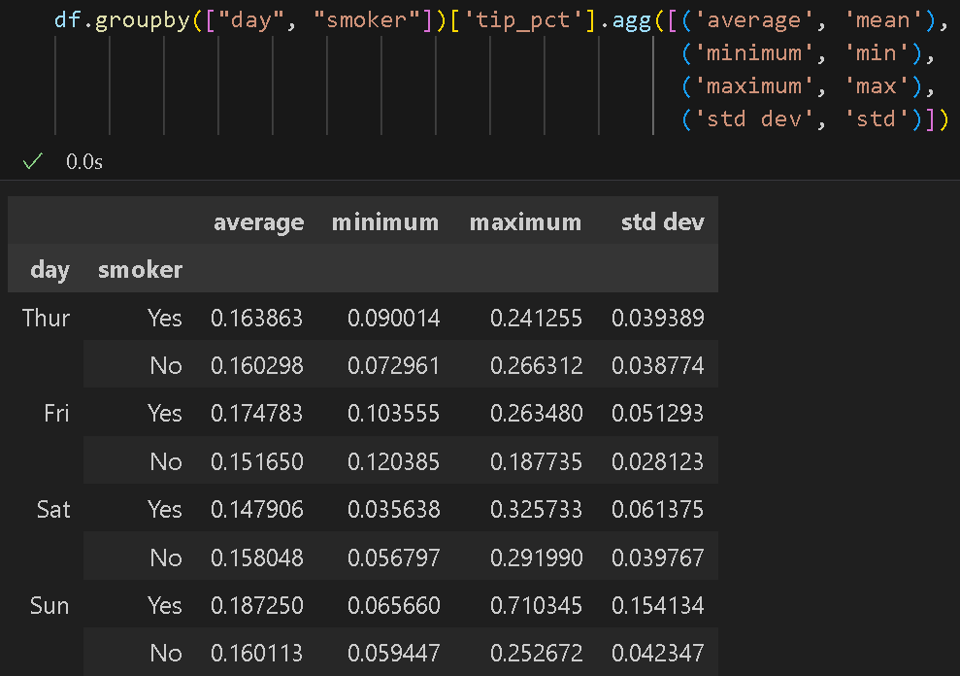
- We can also aggregate on a dictionary of axis labels as a key and functions as values, as
Follow. Type the following code in a new code cell and run it to see the output:

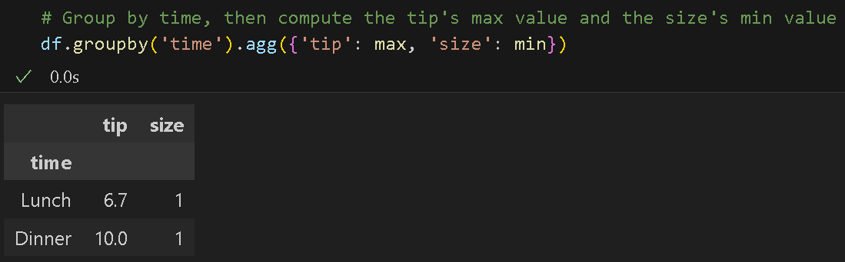

Here we applied the max and min functions to the tip and size columns, respectively.

Apply: We can use apply to calculate an arbitrary function on a grouped result. It splits the object into pieces, invokes the function being passed on each piece, then concatenates the pieces. Unlike transform, this works on the entire DataFrame at once.

- Type the following code in a new code cell and run it to see the output:

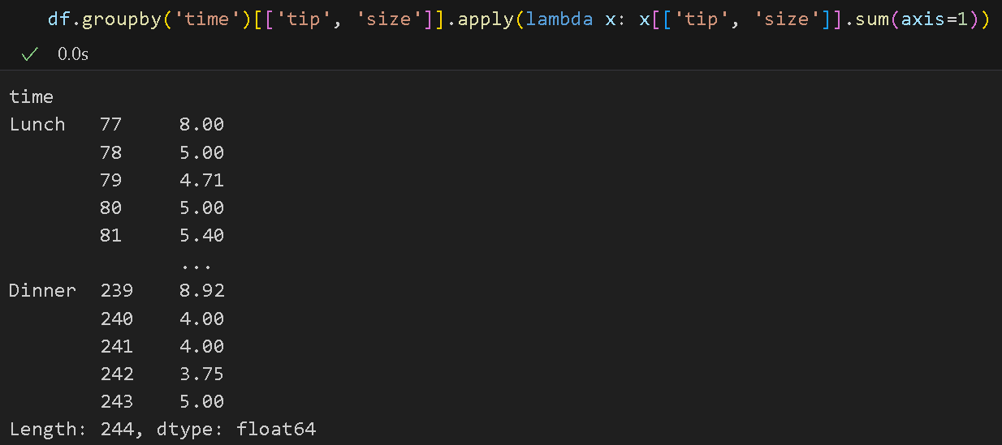

Note that the function passed to apply must take a DataFrame as its first argument and return a DataFrame, Series, or scalar.

- We can also fill missing values using groupby and apply. Let us add a new row to our DataFrame. Type the following code in a new cell, then run to see the output:
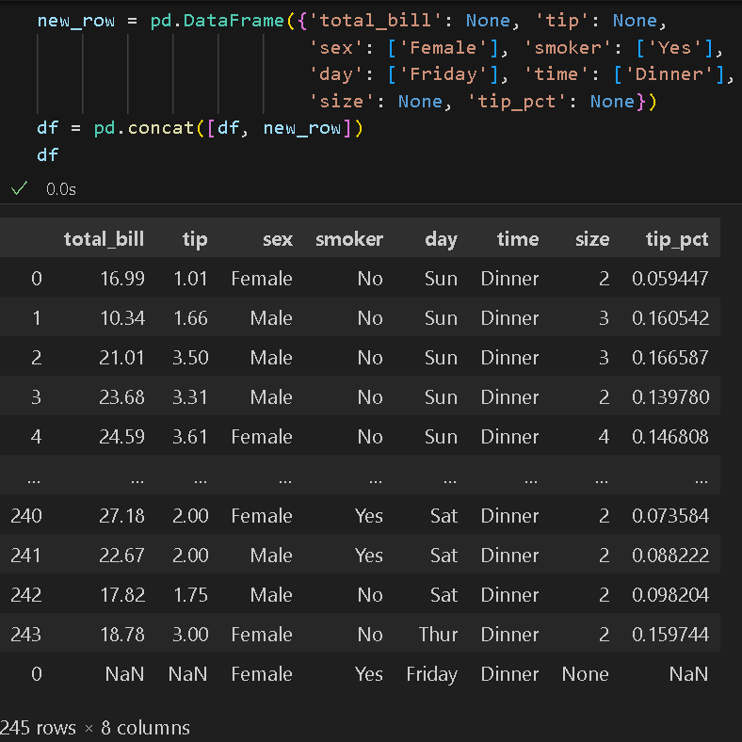

- Then type the following code in a new code cell and run it to see the output:

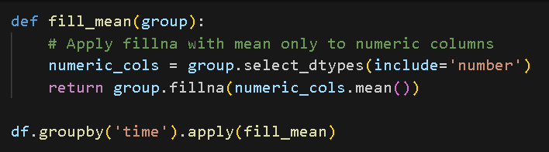
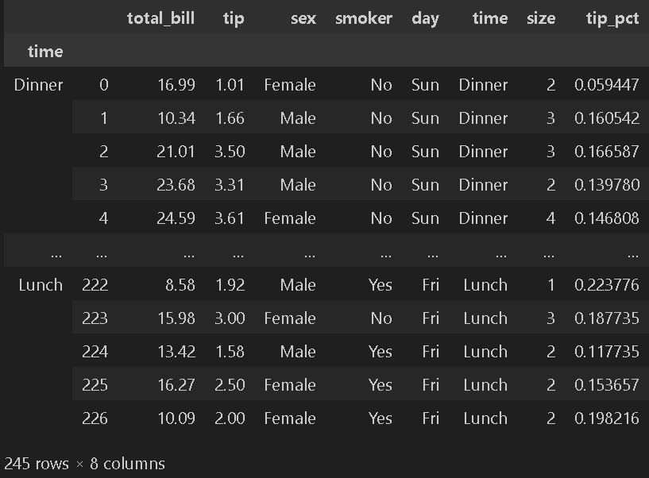

Transformation: A transformation applied to a group or column returns an object that has the same size as the original data being grouped. Therefore, the transform result must match the size of the group chunk.
- Before performing the aggregation operation, let us drop the row with missing values. Type the following code in a new code cell and run it to see the output:
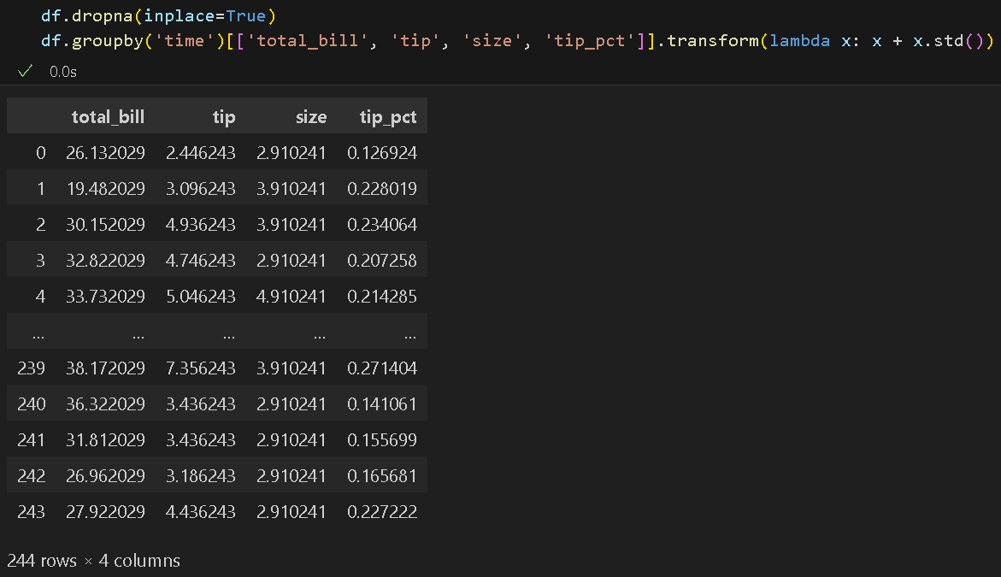

In this example, we modified the original values by adding the standard deviation to each value and applied this logic to the entire DataFrame. Behind the scenes, transform applies this operation to each column individually. Similarly, transform() takes a function as a parameter.

Two main differences between apply and transform:
- apply passes all columns to the custom function.
- apply to return a scalar, Series, or DataFrame.
- transform passes each column as a Series to the custom function.
- transform must return a Series with the same length as the group.
- The downside of apply is that it is slower than transform, so try to use other functions before using apply.

Filter: The filter() function filters data based on a defined criterion and returns a subset of data, depending on the group properties.
- Type the following code in a new code cell and run it to see the output:
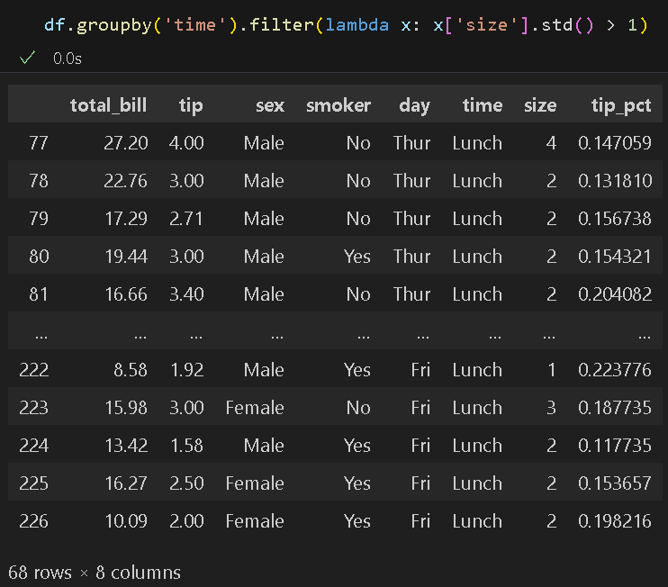

In this example, the code filters the DataFrame, ‘df,’ based on the standard deviation of the 'size' column within each group defined by the 'time' column. Only the groups with a standard deviation of the 'size' values greater than 1 are kept in the result. The resulting DataFrame contains rows from the original DataFrame, but only from the groups that passed the filtering condition.

Pivot Table
A pivot table is a data summarization tool frequently found in spreadsheet programs and other data analysis software. It aggregates a table of data by one or more keys, arranging the data in a rectangular grid with some group keys along the rows and others along the columns.
The pivot_table method conveniently summarizes, sorts, reorganizes, groups, counts, totals, or averages data. It enables us to transform columns into rows and vice versa and supports grouping. It functions similarly to the groupby method but offers more customization options. It is more flexible and easier to use, and the results are easier to analyze.

- Type the following code in a new code cell and run it to see the output:

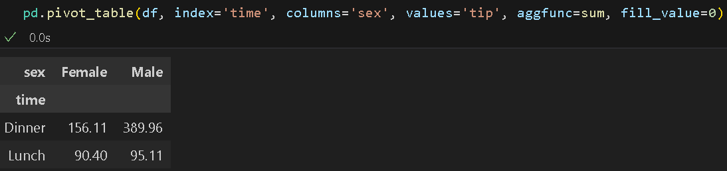

The code creates a pivot table that summarizes tip amounts by time (rows) and sex (columns). For each combination, it sums up the tip values. If any combination has no tip values, it will fill the resulting cell with 0 instead of leaving it empty. This shows us which gender contributes the most in tips and identifies the time periods with the highest tip amounts.

You can learn more about Data Aggregation here: https://pandas.pydata.org/pandas-docs/stable/reference/groupby.html.

*** This is the end of the HOS9A exercise. Please answer HOS09B in Brightspace after pushing your work to GitHub. ***

Push your work to GitHub.
Follow the instructions on the CityU STC TA Center Github.io Submit your work page.
You may also follow the instructions below:

- Open the cmd terminal for Windows users,
- After selecting the + button, make sure the terminal is cmd if you have not closed the Python terminal. If the terminal is not cmd, open the drop-down box and select the Select Default Profile option.
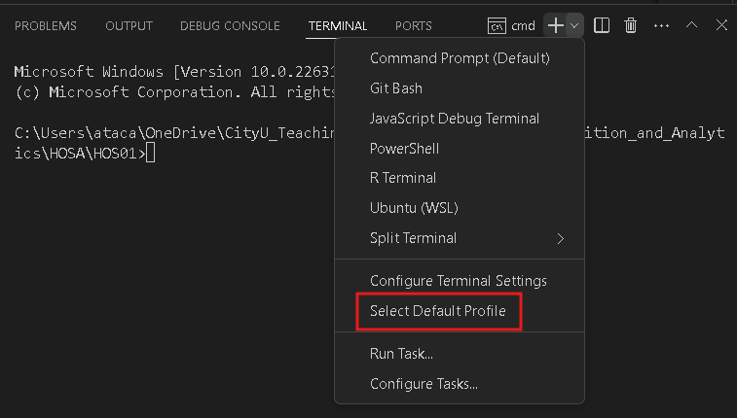

Look for and then select Command Prompt.
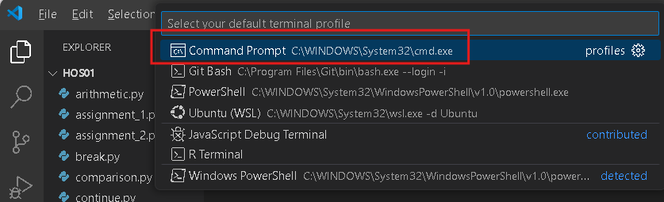

Click the + button. The command prompt will open.

- Make sure you are in the correct directory/repository: Desktop/DS522/hos09a-courseName-yourUserName. Run the following commands to push your work to the GitHub repository:
- Open the terminal from VSCode by hitting the control + ~ key and type the following command:
>>> git add .
>>> git commit -m “Submission for HOS07A-1.”
>>> git push

